# Nuclei Properties Example Workflow

1. Ensure that the repository and subfolders are added to the MATLAB path, and run the following in the command window:

ia = nucleiExample();

1. Select Experiment>New Experiment>Yokogawa.. from the menu of the window that appears: 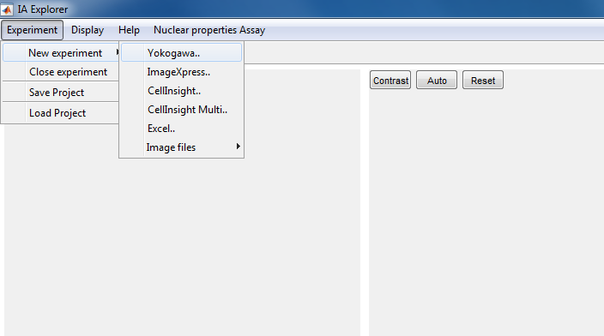
2. Navigate to the folder that contains the experiment images (for this example, they are stored in Examples\Nuclei\AssayPlate within the repository: 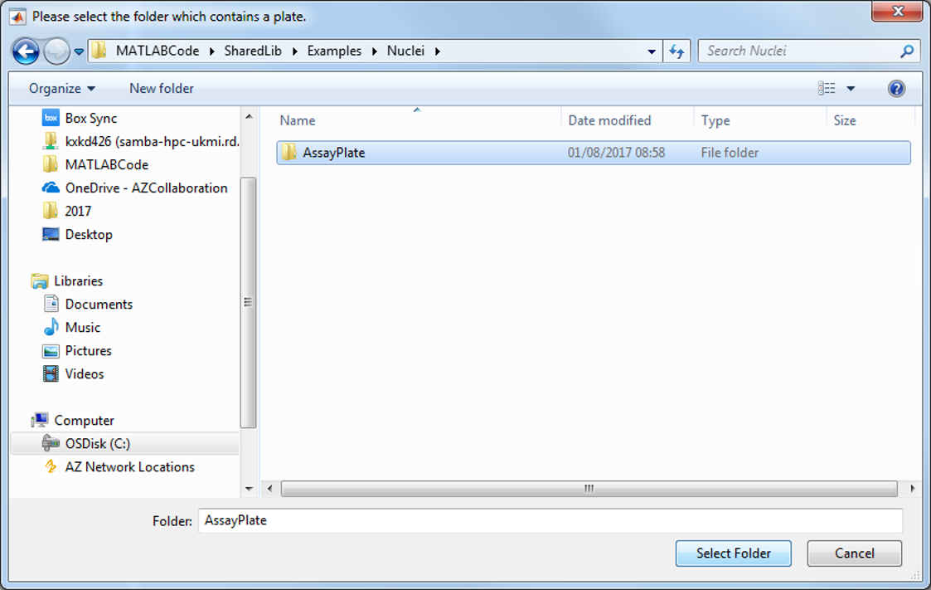
3. The plate map and image hierarchy for the experiment appears in the ‘browser’ panel on the left: 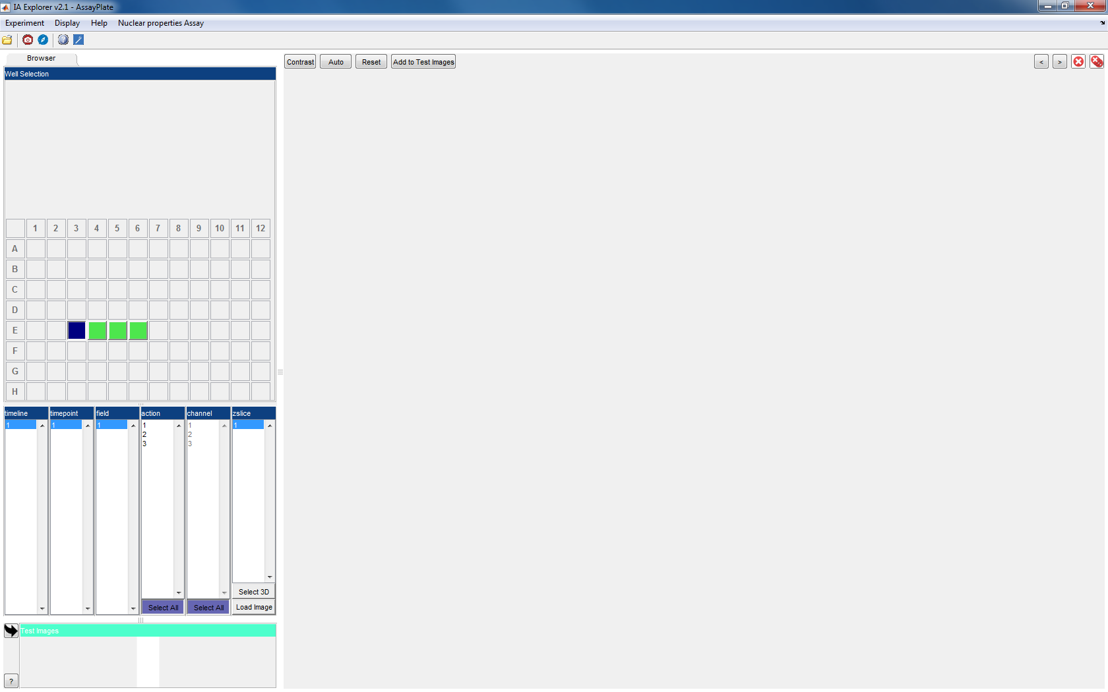
4. Select an appropriate well (or keep the initial selection) and click ‘load image’ at the bottom of the browser panel. The image is displayed on the right hand side: 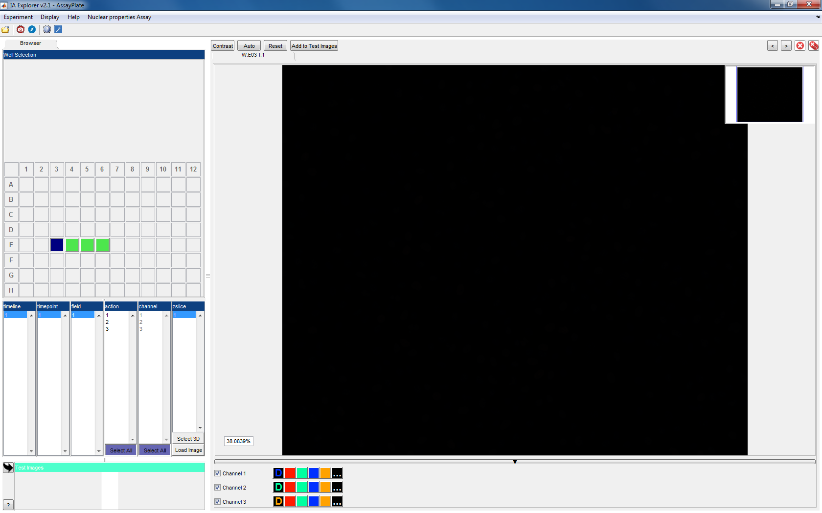
5. The image is shown without any contrast adjustment – click the ‘Auto’ button at the top of the display to automatically adjust the contrast (the ‘Contrast’ button allows manual fine tuning of the display contrast) 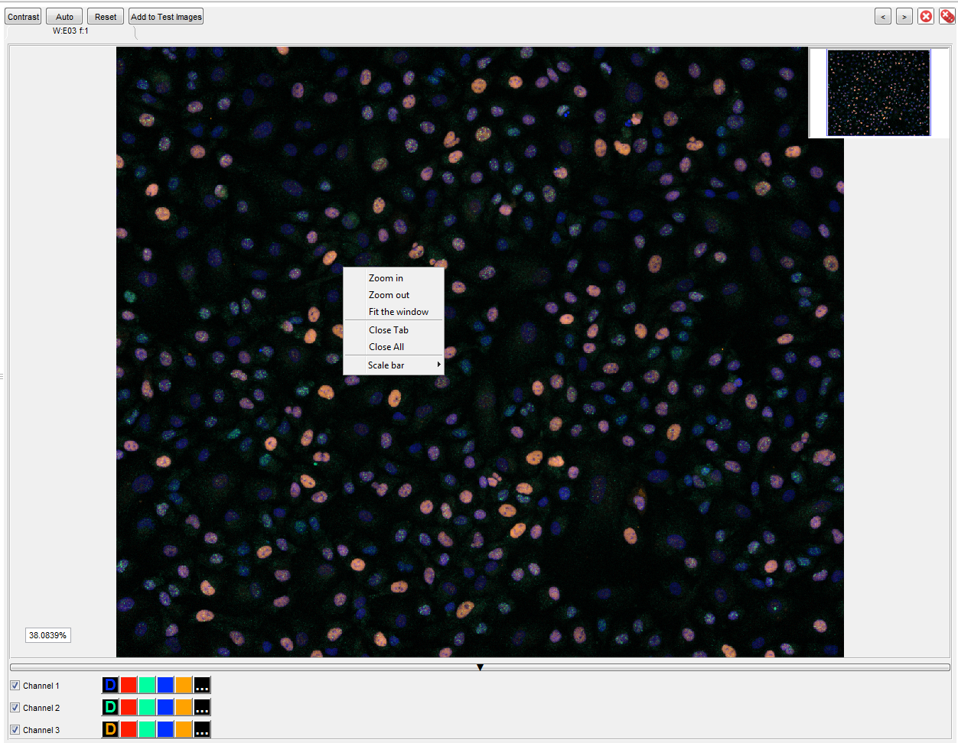To adjust the image magnification, right click and choose zoom in or zoom out, or use the mouse scroll wheel.
6. Set the output folder, where results of the batch run will be stored: 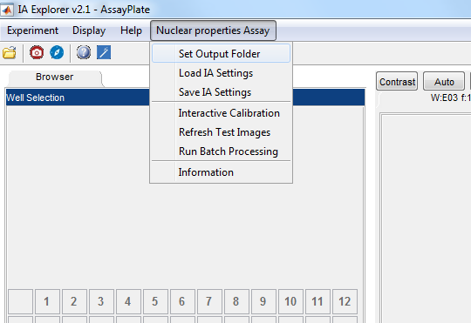
7. To adjust image processing settings, select Interactive Calibration from the Nuclear Properties Assay menu. This will run the image processing workflow on the currently selected image – to run the calibration on multiple images, use the ‘Add to Test Images’ button to build a set of images, before selecting interactive calibration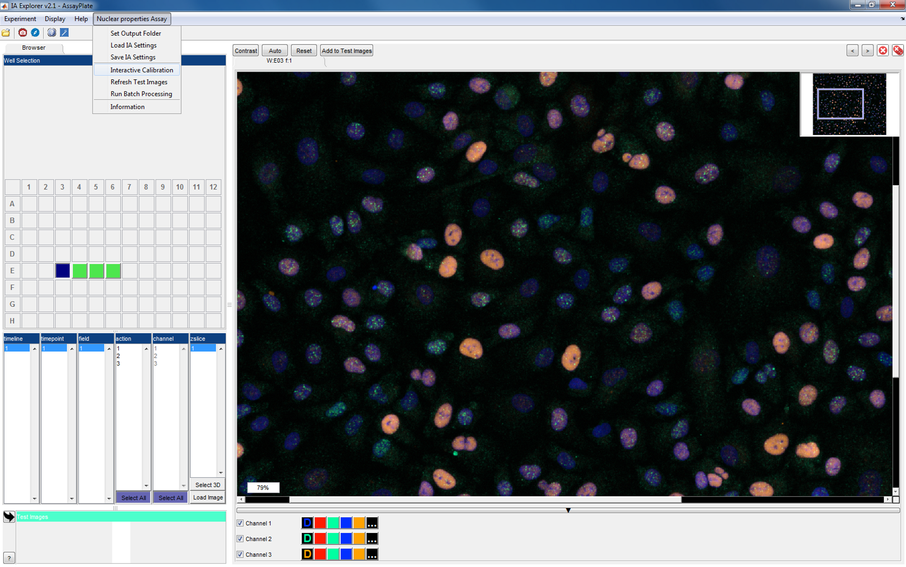
8. The window that appears lists the parameters than can be adjusted for each step of the image processing. The values can be adjusted using the sliders or the edit boxes. To apply changes to the settings, click the Apply stage button. To apply the changes and see the resulting segmentation, click the ‘Run Stage’ button: 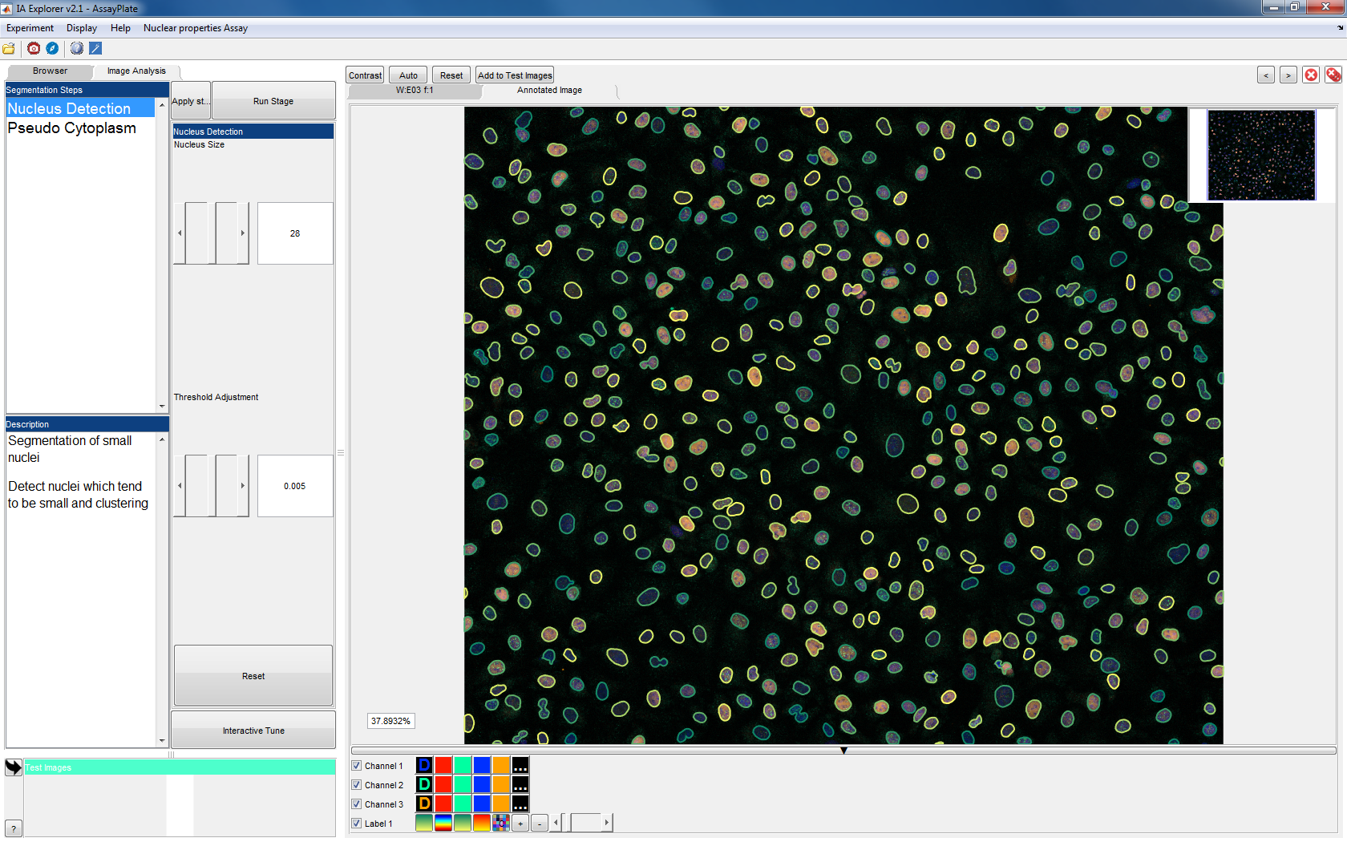
9. Select the second segmentation stage ‘Pseudo Cytoplasm’ in the left panel, and ‘Run Stage’: 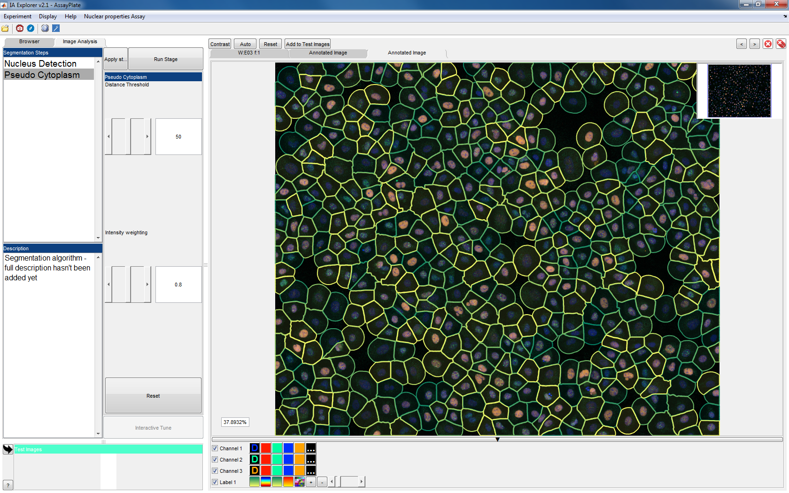
10. When happy with the settings, select ‘Run Batch Processing’ from the Assay menu, and follow the prompts: 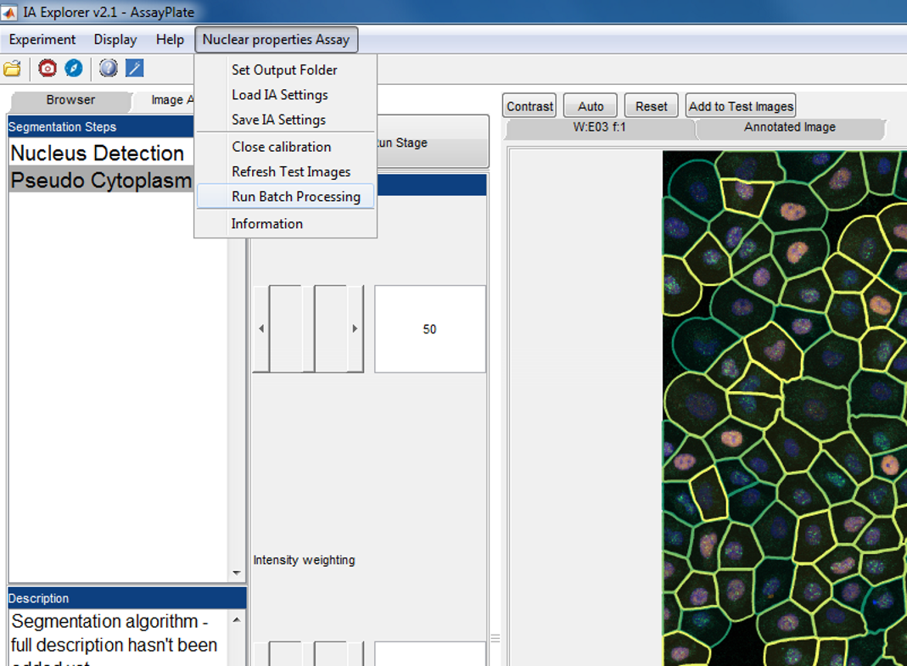

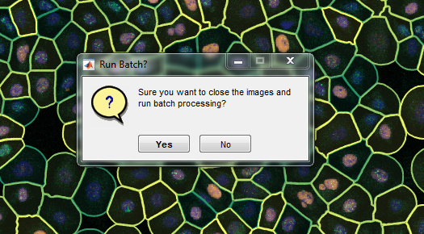

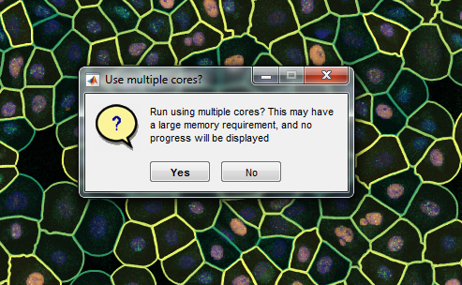

1. If run without parallelising, progress is displayed: 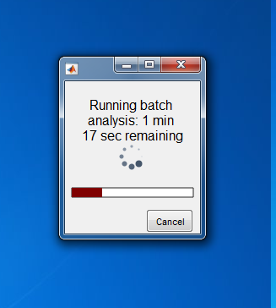
2. Results are stored in the chosen output folder: 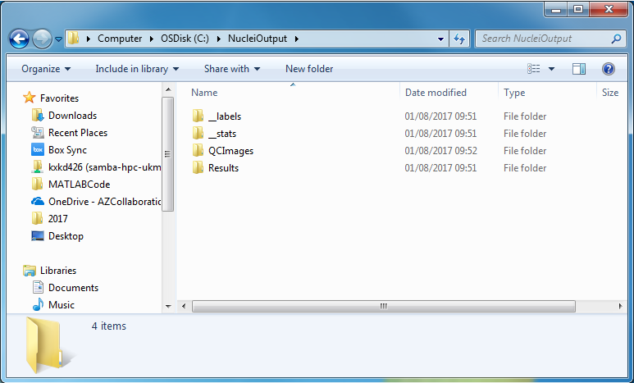The folders __labels and __stats contain single cell results stored as .mat files. QCImages contains images showing the segmentation results. The measured single cell properties are stored as semicolon separated data file in the Results folder. This can be imported directly into one’s chosen analysis software.

This command reads the results into MATLAB (after setting current directory to the output folder) as a table:

T = readtable('Results/Results_AssayPlate.csv','delimiter',';'); 